**DBMS MANUAL**

**Name :** K M PADMASRI Roll.No:230701223

Writing Basic SQL statements

**Ex.no.3:**

1.DESC EMP;

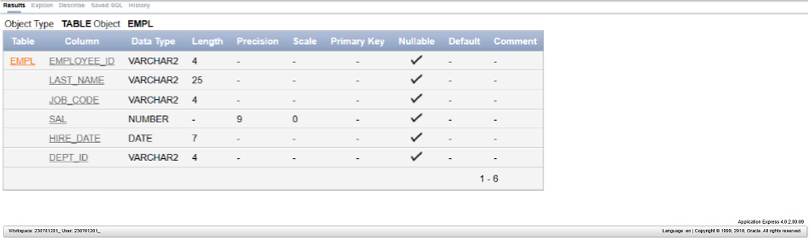

2. Select Employee_id, Last_Name ,Job_code, hire_date from EMP;

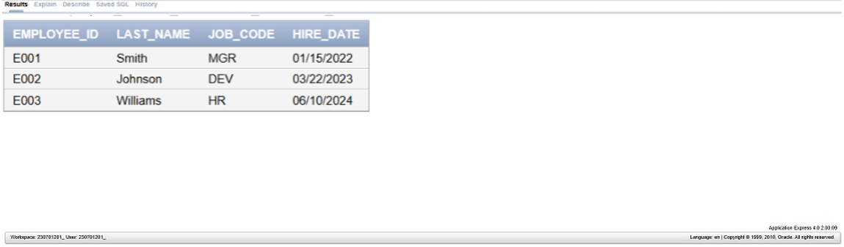

3. Select Employee_id, Last_Name ,Job_code, hire_date from EMP;

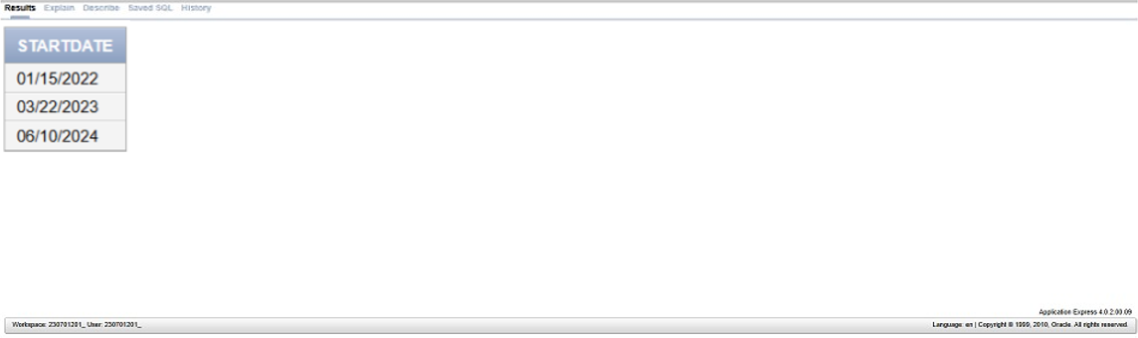

4. select distinct Job_code from EMP; 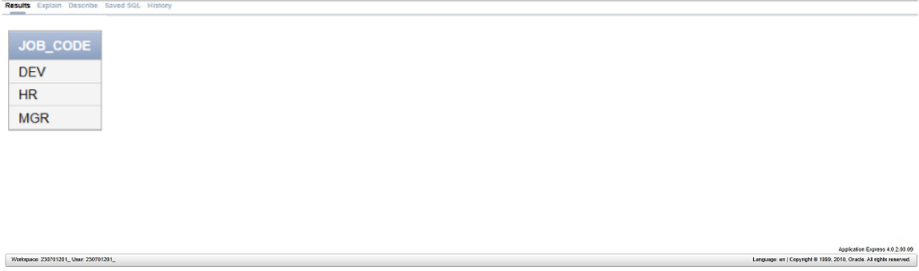

5. Select Last_name ||’,’|| Job_code as “Employee and title” from EMP;

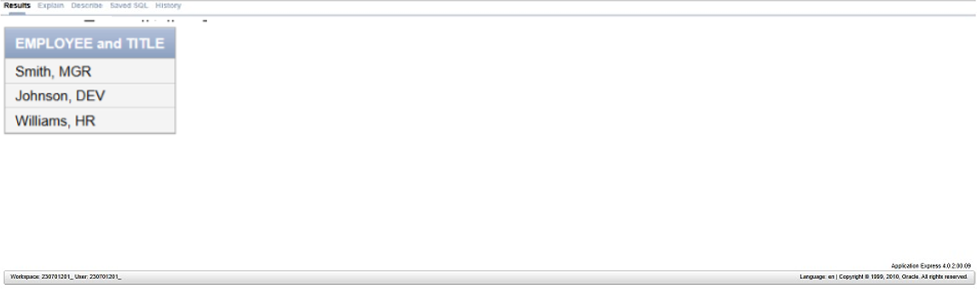

6. Select employee_id ||’,’|| first_name ||’,’|| last_name ||’,’|| email ||’,’|| phone_number ||’,’|| hire_data ||’,’|| Job_code ||’,’|| salary ||’,’|| commission_pct ||’,’|| manager_id ||’,’|| department_id as “THEOUTPUT” from EMP;

